Assignment 4

1. Create your own genetic operators (at least one adaptive) for continuous optimization and compare them to the default settings. You do not have to use all the functions from the BBOB benchmark. Select 4-5 of them from different groups.
2. Send me a plot comparing your operators with the default settings for each of the functions you have selected. Try to comment the results with respect to the features of the selected functions.

Without changing the code:

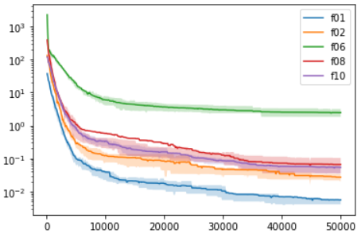

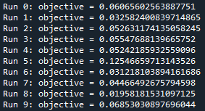

**With changing adaptation**: (With Max. Generation-50)

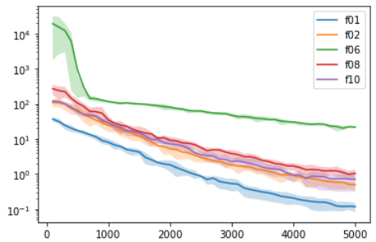

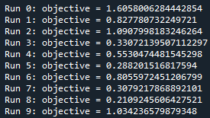

(With Max. Generation-500)



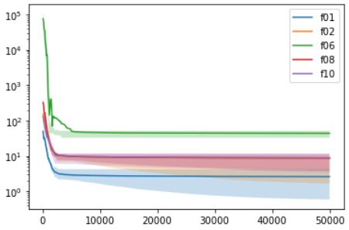

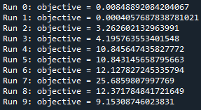

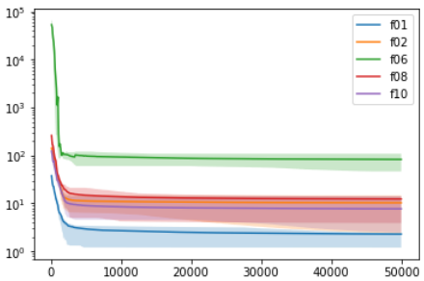

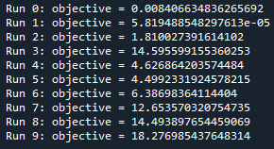



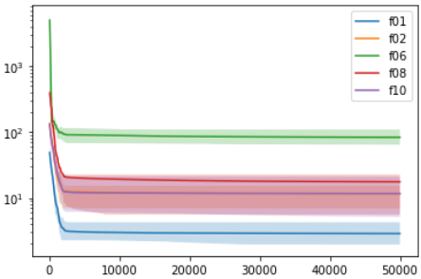

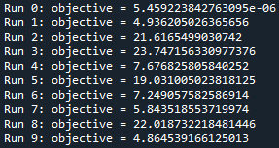

**Trialling with the value**:

Changing the mutation probability…



